AI study assistant: An intelligent learning support application

Table Of Context

1.Introduction: 1
2.Problem Statement: 2
3.Objectives: 3
4. Literature Review: 4
5. Existed Solutions/Related work: 6
6.Proposed solutions: 9
7.Methadology: 13
8.Tools used: 14
9.Implementations 15
10.Result: 15
11. Conclusion: 16
12.Future work: 16
13. References: 17

1.Introduction:
Artificial Intelligence has increasingly become an important technology in education, particularly through intelligent tutoring systems and generative AI applications. AI based educational systems can support learning by providing students with personalized assistance, feedback, and access to learning resources. A systematic review by Lin, Haung and Lu (2023) found that AI has been increasingly applied in intelligent tutoring systems and other educational settings, highlighting its potential to support learning and improve educational experience.
The emergency of generative AI and large language models has further expanded the possibilities for AI-supported learning. Tools such as ChatGPT allow students to interact with AI using natural language and receive explanations, answers and learning support. Research examining experimental studies has reported that AI-based inventions can have positive effects on academic performance, affective-motivational outcomes, and higher-order thinking propensities, although researchers also emphasize the need for careful interpretation and further investigation of long-term effects.
University students often need additional academic support outside the classroom when they encounter difficult concepts, unfamiliar terminology, or problems that require further explanation. Traditional learning resources such as textbooks, lecture notes, and online searches can provide useful information, but students need more interactive and accessible way to ask questions and receive explanations according to their individual needs.
To address this need, this project proposes an “AI Study Assistant”, a mobile application designed to provide students with interactive AI-based academic support. The application allows users to select a subject, enter questions related to academic concepts, and receive AI-generated explanations through conversational interference. It also provides chat history so that students can review previous learning interactions. The proposed system aims to make academic assistance more accessible, interactive, and convenient while demonstrating practical application of artificial intelligence in education.
The project focuses on developing a working prototype that combines a mobile application interface with an AI-based question answers workflow. Rather than replacing teachers or traditional learning resources, the proposed application is intended to function as a supplementary learning tool that can help students to understand concepts and obtain immediate assistance when required.

2.Problem Statement:
University students frequently require additional academic support when they encounter difficult concepts or need clarification outside regular classroom interaction. Traditional learning resources such as textbooks, lecture notes, websites and educational platforms can provide valuable information but they do not always provide an interactive explanation platform tailored to the student’s specific question. The increasing use of conversational artificial intelligence has created new possibilities for providing students with immediate and interactive learning support. Research on ChatGPT in higher education shows that its applications have been expanded across different educational activities and that it is being explored as a tool for supporting students and other academic users ((Baig & Yadegaridehkordi, 2024).).
Another issue is that the educational value of AI assistance cannot be assumed simply because an AI system can generate answers. A systematic review and meta-analysis of 69 experimental studies found positive effects of ChatGPT interventions on academic performance and some other learning outcomes, but the researchers also identified methodological limitations and called for further research into long-term effects and the quality of learning outcomes (Crompton & Burke, 2024). This indicates that AI should be designed and used as a learning-support tool rather than simply as an answer-generation system.
Therefore, there is a need for a student-focused application that provides a structured and accessible way for the university students to interact with AI for academic assistance. The proposed “AI Study Assistant” addresses this problem by providing a dedicated mobile interface in which students can select a subject, submit academic questions, receive AI-generated explanations, and review previous conversations through chat history. The system is intended to make AI-based academic support more organized and convenient while acknowledging the limitations and risks associated with generative AI.
The central problem addressed by this project is therefore:
“University students need an accessible and interactive way to obtain academic explanations and learning support, while existing general-purpose AI-tools may not provide a dedicated, structured and student-focused learning environment. The proposed AI Study Assistant aims to address this problem through a subject-oriented conversational learning application.”

3.Objectives:
The main objective of this project is to develop an AI study assistant that provides students with an accessible and interactive way to obtain academic explanation and learning support. The system is designed to use a conversational AI approach so that students can ask questions in natural language and receive understandable responses.
The specific objectives of this project are given below:
1.to develop a user-friendly mobile application that provides students with a simple and convenient interface for accessing AI learning support.
2.to provide subject selection functionality so that students can choose relevant subject before interacting AI study assistant
3.to develop AI chat interface through which students can enter academic questions and receive AI generated explanations.
4.to provide clear and understandable explanations that can help students better understand academic concepts rather than simply providing short answers.
5. to maintain chat history so that students can review previous questions and explanations.
6.to provide a clear chat option that allows students to remove the current chat and start a new learning session.
7.to implement appropriate user-interface states, including loading indicators, empty states and error handling, to provide a user-friendly experience.
8.to evaluate the functionality and usability of the developed application and identify its strength, limitations and possible improvements.
9.to demonstrate a practical application of AI in education through a working student-focused learning support system.
10. Chat history feature so that the students can review and revisit previously generated explanations through organized chat.
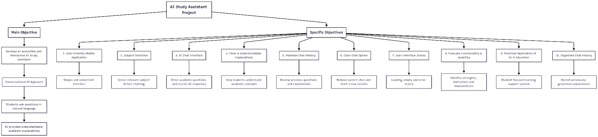

4. Literature Review:
Artificial Intelligence (AI) has become an important area of research in education because of its potential to provide students with personalized learning support, automated feedback, and interactive educational experiences. Research on Artificial Intelligence in Education (AIED) has examined several applications, AI assistants, intelligent, tutoring systems, and systems for managing student learning. These applications demonstrate that AI can be used not only to automate educational tasks but to support students during the learning process.
4.1 Artificial Intelligence in Education:
One important application of AI in education is the development of intelligence tutoring systems designed to provide students with individualized instructional support and feedback. Lin et al. (2023), in a systematic review of AI in intelligent tutoring systems, found that AI-based tutoring systems can support personalized instruction and learning processes. Such systems demonstrate the potential of AI to provide learning assistance according to students' needs rather than relying only on a fixed instructional approach.
The development of AI-based educational systems has therefore created opportunities for students to receive additional learning support outside conventional instructional settings. However, the effectiveness of these system designs, quality of feedback, and responsible implementation.
4.2 Generative AI and ChatGPT in Education:
The emergence of generative AI has expanded the possibilities of AI-based educational support. Conversational systems such as ChatGPT allow users to interact with AI through natural-language questions and receive generated responses. Alba Darin et al. (2024) reviewed empirical research on ChatGPT in education and found that students had used ChatGPT as a virtual intelligent assistant for immediate feedback, explanations of complex topics, personalized learning, and assistance with academic tasks.
This type of interaction is particularly relevant to the proposed AI study assistant because the project is based on conversational interference. Instead of requiring students to search through multiple resources, the application is designed to allow them to enter a question and receive the AI generated explanation within the same learning environment.
4.3Benefits of AI learning support:
Research suggests that generative AI can provide several potential benefits for learning. Deng et al (2025) conducted a systematic review and meta-analysis of 69 experimental studies and reported positive effects of AI-based interventions on academic performance, effective motivational outcomes and higher-order thinking propensities. However, the researchers also emphasize that the finding should be interpreted carefully because of the methodological limitations and the need for further research into long term effects.
Student engagement is also an important consideration. Lo it al (2024) reviewed 72 studies examining the relationship between AI and students. Their findings indicated that the AI-supported learning system can produce both engagement and disengagement, highlighting the importance of AI being incorporated into the learning process.
These findings suggest that AI can be useful as a learning support tool when it is designed to encourage interaction and understanding rather than simply providing answers.
4.4 Challenges and limitations:
Despite its potential benefits, the use of generative AI in education also presents different challenges.AI- generated responses may not always be accurate, and students may incorrectly assume that an AI-generated answer is reliable. There are also concerns related to over-reliance on AI and the possibility that students may use AI without sufficiently engaging with the learning material.
The systematic review by Alba Darin et al. (2024) identified both positive and negative aspects of ChatGPT use in education and emphasized the importance of responsible implementation. Similarly, Deng et al. (2025) noted that existing research requires stronger methodologies and longer-term investigations before the educational effects of ChatGPT can be fully understood.
Therefore, an AI learning application should be viewed as a supplementary learning tool rather than a complete replacement for teachers, textbooks, or other educational resources.
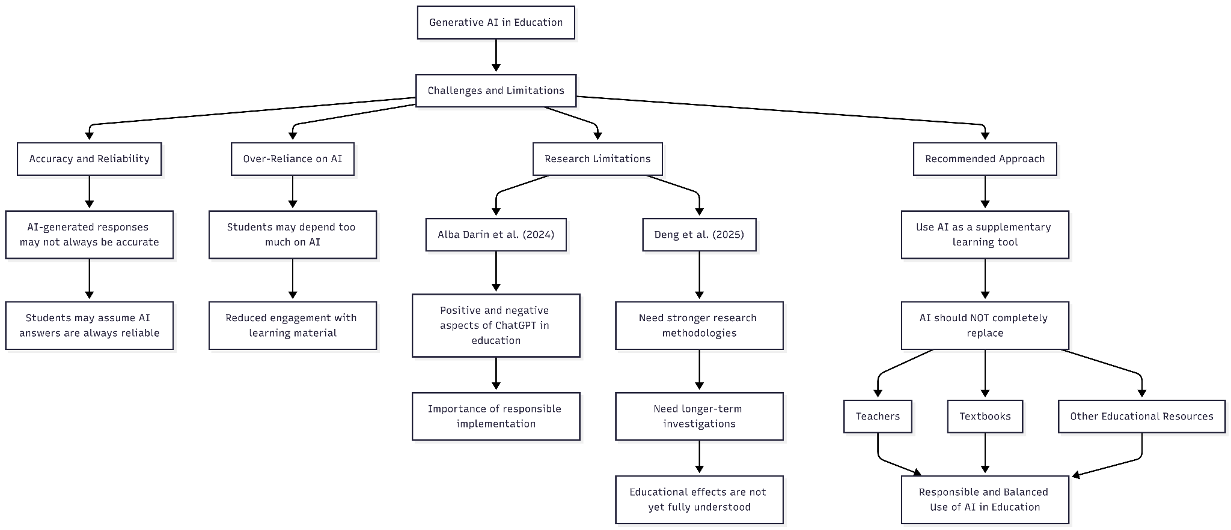
4.5 Research Gap:
Existing research demonstrates considerable interest in AI assistants, intelligent tutoring systems and generative AI for educational effects at a broader level. There is still practical value in developing focused, student-oriented applications that combine conversational AI with a simple learning workflow.
The proposed AI Study Assistant addresses this practical gap by bringing several learning support functions into a single mobile application. The system provides subject selection,
conversational question-answer interference, AI-generated explanation, chat history, and basic interference features such as loading indicators, empty states and error handling.
Rather than attempting to replace existing educational systems, the proposed application focuses on providing students with an accessible environment for asking academic questions and reviewing explanations. The literature therefore provides a foundation for the proposed system while also highlighting the importance of responsible AI use, appropriate interference design, and evaluation of the systems usefulness and limitations.

5. Existed Solutions/Related work:
Several AI-based educational solutions are currently available to support students with learning, explanations, practice, and academic questions. Examining these systems is important because it helps identify existing approaches and provide a basis for designing a proposed AI study assistant.
5.1 Khan Migo:
Khan Migo is an AI-powered tutor and teaching assistant developed by the academy. It is designed to guide learners through simple problems rather than simply providing direct answers. According to Khan academy, Khan Migo can support learning in areas such as mathematics, science, humanities reading, language, arts, computing and test preparation. Its tutoring approach emphasizes questioning learners to work forward answers themselves
(Khan Academy,2026).
Khan Migo demonstrates how conversational AI can be incorporated into the educational environment with an emphasis on active learning. However., it is closely connected to the Khan academy ecosystem and its educational content library. The proposal AI study assistant takes a different approach by focusing on a simple, general -purpose student learning interface in which students can select a subject and ask questions for AI – generated explanations.
5.2 ChatGPT Study Mode:
ChatGPT also provides a dedicated study mode designed to support the learning through step-by-step guidance. According to OpenAI, Study mode can ask questions, guide student’s thinking, explain concepts step-by-step, check understandings, create practice questions and help students prepare for tests. It can also work with uploaded learning materials when file uploads are available.
ChatGPT demonstrates the usefulness of conversational AI and the learning assistant. However, it is a broad general-purpose AI system rather than a specifically designed workflow of a proposed AI Study assistant. The forced application focuses on a more limited and clearly defined set of educational functions, including subject selection, question-based interaction, explanation, chat history, and a clear chat option.

Gemini Learning Tool:
Google Gemini also provides learning-oriented capabilities. Its learning tools include guided learning, practice questions, feedback, hints, visual aids, and educational resources. Gemini can also use uploaded files or images in learning interactions, and google provides options for using reputable educational sources such as OpenStax in certain learning flows (Google, 2026).
Gemini provides a broad collection of AI capabilities beyond the specific scope of a student learning assistant. The proposed project intentionally focuses on a smaller set of features. that can be implemented and evaluated within a student-oriented mobile application.
5.4 Intelligent tutoring system:
Beyond individual commercial AI products, intelligent tutoring systems represent an established research area in AI supported education. ITS is designed to provide students with instructional assistance and feedback that can be adapted to learning needs. Recent research indicates that AI study assistance can have generally positive effects on student learning and performance.
The research also highlights the need for longer interventions, larger and more diverse samples and further ethical issues surrounding AI based teaching. These findings are important for the proposed project because they show both the potential of AI-based tutoring and the importance of responsible system design and evaluation.
5.5Comparison of existing solution:
The existing solutions demonstrate different approaches to AI supported learning. Khan Migo emphasizes guided tutoring and is integrated with khan academy educational content.
ChatGPT provides step by step learning assistance within a conversational environment.
Gemini can provide guided learning together with additional AI powered study and content generation capabilities.
The proposed AI assistant is initially narrower in scope. Instead of attempting to reproduce all capabilities of large AI platforms, it focuses on creating a simple and structured learning workflow for students. This makes the project more manageable to implement while allowing the core learning interaction to be demonstrated clearly.

Feature | Khan Migo | Chat GPT study mode | Gemini learning tools | Proposed AI study assistant
Conversational interaction | ✅ | ✅ | ✅ | ✅
Academic explanation | ✅ | ✅ | ✅ | ✅
Guided learning | ✅ | ✅ | ✅ | Planned
Practice questions | ✅ | ✅ | ✅ | Feature enhancement
Subject selection | Educational content-based | General | General | ✅
Dedicated simple learning workflow | Education ecosystem | General AI platform | General AI platform | ✅
Chat history | Platform Feature | Platform Feature | Platform Feature | ✅
Clear current chat | Platform Feature | Platform Feature | Platform Feature | ✅

5.6 Design and Research gap:
The reviewed solution shows that AI can support students through conversational interaction, guided explanations, practice activities and personalized learning experience. At the same time, these systems are generally broad platforms with extensive features and ecosystems.
The proposed AI study assistant addresses a practical design gap by focusing on a smaller clearly defined workflow. The application is intended to provide students with a straightforward way to select a subject, ask an academic question, receive an explanation, and review previous explanations. This focused approach makes the system suitable for a student project while still applying concepts demonstrated by existing AI learning systems.
The literature and existing solutions therefore provide a foundation for the proposed application. They also indicate that successful learning AI tools should be designed with attention to learning support, usability, responsible AI use and the limitations of AI generated responses.

6.Proposed solutions:
The proposed solution is the proposed AI-study assistance, an intelligent learning support application designed to help students understand academic concepts through an interactive and simple mobile interface. The application allows a student to select a subject, enter an academic question and receive an AI-generated explanation.
The proposed system combines conversational artificial intelligence with a focused learning workflow. Instead of requiring students to use a general-purpose AI platform, the application provides a dedicated environment where academic questions can be organized around selected subjects. Research on AI-based personalized learning shows that artificial intelligence can support students with personalized content, tutoring, feedback, and learning assistants.
The AI-study assistant is a supplementary learning tool. It is not designed to replace the teachers, textbooks or other educational resources. Its purpose is to give additional support to students when they need explanation or explore academic questions independently.
6.1 Main Features:
The application provides a subject selection feature that allows a student to select a subject they want to study. Selecting a subject helps organize the learning session.
The main feature of the application is the AI chat interface. Students can enter their academic questions into the text input field. The conversational interface allows students to ask follow-up questions instead of starting a new chat.
The application includes chat history so that students can review previous questions and AI generated explanations within their learning sessions. This feature can be useful when the student wants to review previous AI generated explanations.
The application also has a clear chat option which allows students to remove current conversation and begin a new learning session. This keeps different study sessions organized and prevents unnecessary previous messages from remaining in the current conversation.
6.3 Working process:
First, the student opens the application and selects the required subject. The student then enters an academic question and submits it. The application sends the question along with the relevant context to the AI component.
The AI component processes the question and generates a suitable response. The response is then displayed in the application’s conversation interface. The student can continue asking questions, ask for clarification, or start a new conversation using the clear chat option.
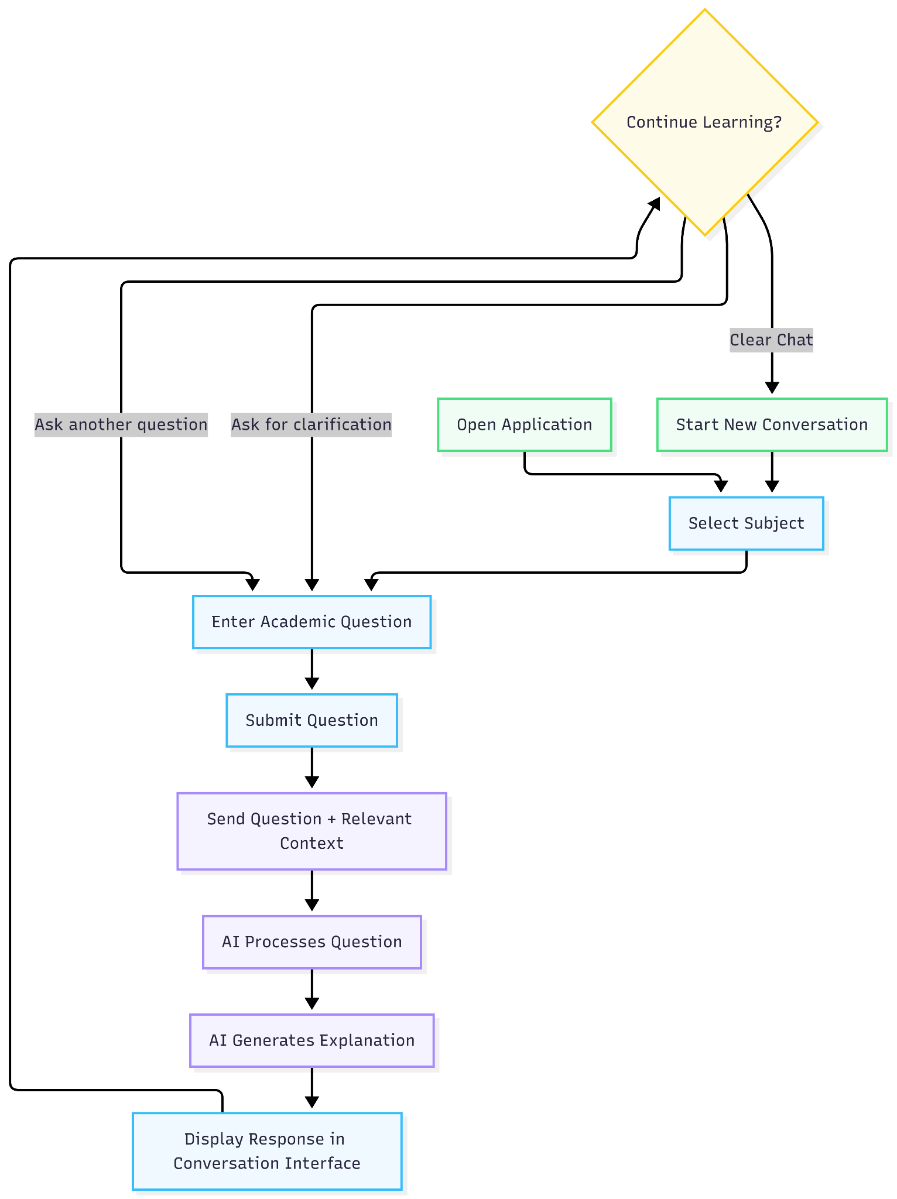

6.4 AI Component:
The AI component is the main intelligent part of the proposed systems. It is responsible for processing student questions and generating relevant academic explanations.
During the initial development stage, “mock AI responses” can be used to develop and test the application’s interface without requiring an external AI API. Once the application interface and functionality are stable, the mock response system can be replaced with a real large language model (LLM) API.
The AI component can receive information such as:
- Selected subject
- Student’s question
- Previous conversion messages
- Instructions for generating educational explanations
The generated response is then returned to the application and displayed to the student. This approach also makes the application modular because the AI service can be replaced or upgraded later without completely redesigning the user interface.
6.5 User Interface Design:
The user interface of the AI Study Assistant is designed to be simple, clean, and student-friendly. The application should avoid unnecessary complexity and focus on the main learning task.
The main interface includes subject selection, a button, a conversation area, and AI responses are loading indicators. And a clear chat option.
The design should provide appropriate and empty messages. This element helps students to understand what they should do when they open the application while the question is being processed and when a problem occurs.
6.6 Advantages of proposed solution:
The proposed AI Study Assistance provide several potential advantages:
- Interactive learning supports students to ask questions and receive responses through conversational interchange.
- “Structured learning environment” subject selection provides a focused environment for academic questions.
- “Independent Learning” Students can seek explanation and explore concepts at their own pace.
- “Simple User Experience” The application focuses on essential learning functions rather than unnecessary features.
- “Expandable System” Additional features such as quizzes, program tracking, and personalized study plans can be added in future versions.
- “Practice AI Application” The project demonstrates how AI can be integrated into an educational application to provide learning support.
  - Scope Of Proposed System:
The initial version of an AI Study Assistant will focus on a following function
- Subject selection
- AI conversational interaction
- Academic question input
- AI generated explanation
- Chat history
- Clear chat functionality
- Loading indicators
Additional features may be considered as future enhancement including:
- AI generated quizzes
- Student performance analytics
- Voice based
- Personalized study plans
- Progress tracking
- Learning recommendation
6.8 Summary:
The proposed AI solution aims to provide students with an interactive student of additional academic learning support while maintaining a focused and user-friendly experience.

7.Methadology: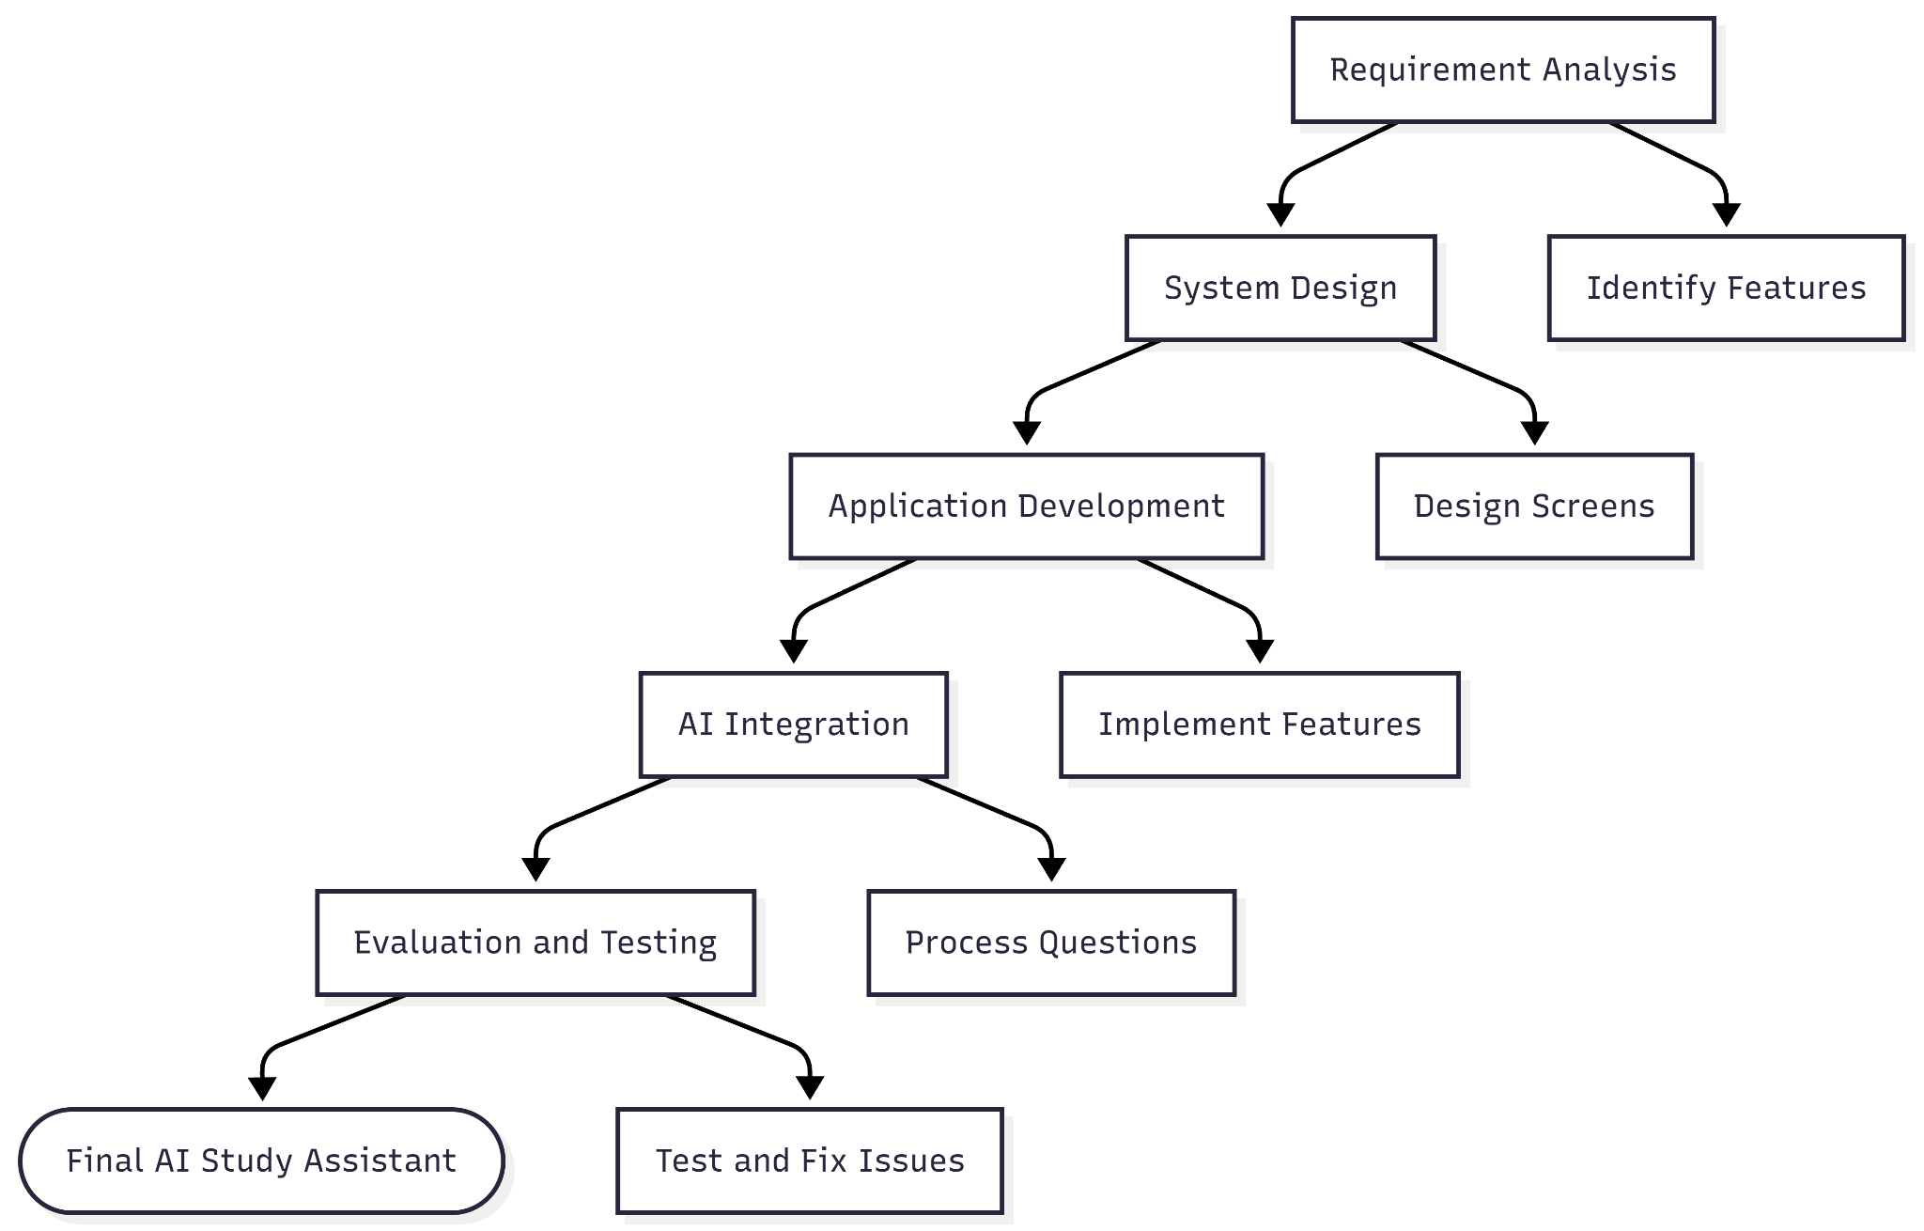

7.1 Requirement analysis:
The first stage of the project is requirement analysis. In this stage, the main purpose and requirements of an AI study assistant are identified. The system is designed to provide students
with an easy way to select a subject, ask academic questions and receive AI generated explanations.
The main requirement includes subject selection, clear history, chat history, loading indicators, and a simple user-friendly interface.

7.2 System design:
After identifying the requirements, the structure and user interface is designed. The application includes screens such as home screen, subject selection screen, ai chat screen, chat history screen.
The AI chat screen is the main screen of the application. It provides the conversation area for displaying massages and an input field through which a student can enter their questions.

7.3 Application development:
The application is developed by using replit. Development begins with creating a Basic structure and navigation. The main features are then implemented step by step.
The development process includes creating the application screens, implementing subject selection, developing the AI chat interface, adding chat history and clear chat functionality, and implementing loading.
7.4 AI integration:
The AI component is responsible for processing student questions and generating academic explanations. During the initial development stage, mock AI responses can be used to test the application's chat functionality without depending on an external AI service.
The student's question, selected subject, and relevant conversation context can be sent to the AI service, and the generated response can then be displayed in the application.
7.5 Evaluating and testing:
The complete application will be tested to ensure that its main features are working correctly. the testing will include subject selection, question submission, AI responses, chat history, clear chat, navigation, loading states. The application will be evaluated according to the objectives defined for the project. Any problems identified during testing will be corrected and the relevant features will be tested again. This process will help ensure that the final AI Study Assistant is functional, user-friendly, and suitable for demonstrating the proposed solution.
8.Tools used:
Replit is used as the main development of the project. It provides the environment to create, develop, run, and test the AI Assistant. The project was developed within Replit using its available development and AI-assisted features.
Replit was selected because it provided an accessible environment for developing and testing applications without requiring a complex local setup. It also helped in managing the project files and running the application during development.
The project was developed and tested directly within Replit. Different features were checked during development to identify errors and improve the functionality of the AI Assistant.
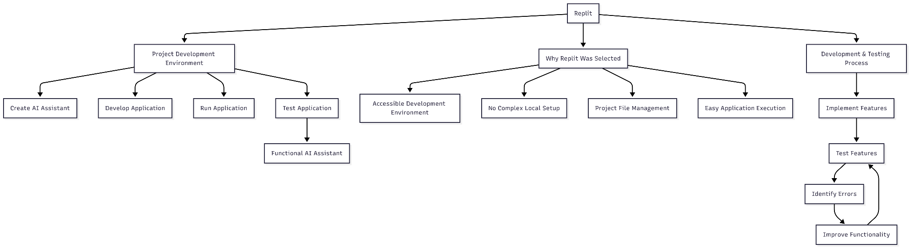9.Implementations
The AI Assistant was implemented using Replit as the main development platform. The project was developed by building the required features and testing them within the Replit environment.
9.1 User Interface Implementation:
A simple and user-friendly interface was implemented to allow users to provide the necessary options for entering questions and receiving responses.
9.2 AI Assistant Implementation:
The AI Assistant was implemented to process user questions and provide relevant responses. The system is designed to make interaction simple and provide useful information to the user.
9.3 Feature Implementation:
The main features of the project were implemented according to the identified requirement. Each feature was tested during development to ensure that it worked as expected.
9.4 Testing and Debugging:
After implementation, the project was tested in Replit. Errors and problems found during testing were identified and corrected to improve overall functionality and reliability of the AI Assistant.

10.Result:
The proposed AI Assistant was successfully developed as a functional project using Replit. The main features were implemented according to the requirements identified during the research.
10.1 User Interaction:
The system allows users to interact with the AI Assistant through a simple interface. Users can provide their questions or requests and receive responses from the assistant.
10.2 AI Response:
The AI Assistant is able to process user input and generate relevant responses. This makes the system useful for providing information, explanations, and assistance to users.
10.3 Testing Results:
The implemented features were tested during development to identify and correct errors. Testing showed that the major functions of the system worked as expected.
10.4 Overall Result:
Overall, the implementation demonstrates that an AI Assistant can be developed as a practical and user-friendly application. The project successfully achieves its main objective of providing users with an interactive AI-based assistance system.
11. Conclusion:
The project successfully demonstrates the development of an AI Assistant designed to provide users with interactive and helpful AI-based systems.
11.1 Achievement of Objectives:
The main objectives of the project were achieved by developing the AI Assistant and implementing its core functionality. The system provides users with a simple way to interact with AI and receive relevant responses.
11.2 Overall Conclusion:
The project shows how AI can be used to develop practice and user-friendly assistant systems. The developed solution provides a foundation that can be further improved with additional features and capabilities.
12.Future work:

12.1Advanced AI Capabilities
Future versions can include improved AI capabilities to provide more accurate, detailed, and personalized responses.

12.2 Voice Interactions:
Voice input and output can be added to allow users to communicate with the AI Assistant using speech.
12.3 Personalization:
The system can be improved to understand individual user preferences and provide more personalized assistance.
12.4 Additional Features:
Future development can include features such as file handling, multilingual support, improved conversation history, and additional user controls.
12.5 Mobile Applications:
The AI Assistant could be extended into a mobile application so that users can access it more conveniently on smart phones and tablets.

13. References:
1.Replit. Replit Documentation.
https://docs.replit.com/
2.National Institute of Standards and Technology (NIST). Artificial Intelligence Risk Management Framework (AI RMF 1.0).
https://www.nist.gov/itl/ai-risk-management-framework
3.National Institute of Standards and Technology (NIST). Artificial Intelligence Resource Center.
https://airc.nist.gov/

